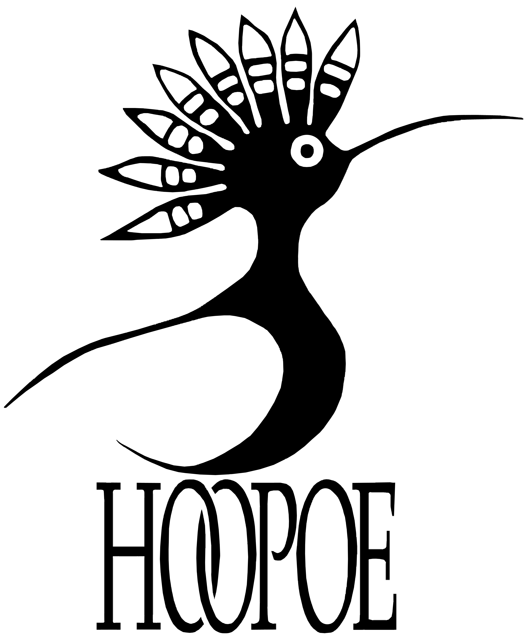

**Farid Bazgar,** Executive Director

**Telephone:** (647) 857-8855

**Email:** faridbazger@kor-af.org

**KOR - Hoopoe Books**

Khatiz Organization for Rehabilitation (KOR)

P.O. Box 4020, Kart-e-Char, Kabul, Afghanistan

www.booksforafghanistan.org

**So that we may provide the materials you need, please complete this questionnaire and email it back to us at** [**faridbazgar@kor-af.org**](mailto:faridbazgar@kor-af.org) **Thank you!**

|  |  |
| --- | --- |
| *Name of Organization:* | *Name:* |
| *Position:* |
| *Address:* | *Email:* |
| *Phone:* |
| TO PROVIDE THESE BOOKS, ETC., WE NEED: |  |
| *Name of Afghan contact for our driver (Dari or Pashto speaker):* |  |
| *Afghan contact’s Phone/Mobile # for our driver:* |  |

**Please confirm the number of copies you wish to receive in each category:**

      copies of each of twelve titles in Dari-Pashto bilingual editions (Grades K - 6)

      copies of each of twelve titles in English editions (Grades K - 6)

      copies of each of four titles in Dari-Pashto bilingual editions (Grades 5 - 8)

      copies of each of four titles in English editions (Grades 5 - 8)

      Teacher Guides in Dari

      Teacher Guides in Pashto

      Teacher Guides in English

**1. How will the books be used?** (*please check all that apply*)

Provided directly to children to take home with them.

Provided to teachers to use in classroom instruction.

Provided to schools/orphanages/community libraries for circulation.

Other. Please specify:

**2. How many will use and benefit from the books?** (*please fill in all that apply*)

**A. Schools**

How many schools do you serve?       (**Please list the names and locations of the schools below or on a separate sheet of paper.**)

How many students/children do you have total?

How many children will receive books to take home?

Boys       Girls

In Grades K – 2:       Grades 3 – 5:       Grades 6 – 8:

How many teachers/classes will use the books during instruction?

In Grades K – 2:       Grades 3 – 5:       Grades 6 – 8:

**____________________________________________________________________________**

**Names/locations of schools served:**

**B. Orphanages**

How many orphanages do you serve?

**Please list the names and locations of the orphanages here:**

How many children do you serve in these orphanages?

How many children will receive their own copies of the books?

Boys:       Girls:

Grades K – 2:       Grades 3 – 5:       Grades 6 – 8:

How many teachers/classes will use the books during instruction?

How many caregivers will use the books?

In Grades K – 2:       Grades 3 – 5:       Grades 6 – 8:

**C. Libraries**

How many libraries do you serve?

**Please list the libraries by name where possible:**

**D. Other** (*please provide details*):

**3. Can you print out the Teacher Guides you need?**  YES  NO

(If not, we will send them to you with the books.)

**4. We can also provide Audio readings of each of the six stories for classroom use. They are read with and without page-turn cues in Dari, Pashto and English.** If you would like to receive these, please let us know the quantity of each you require:-

#       Pashto CDs #       English CDs of each title.

#       Dari cassettes #       Pashto cassettes #       English cassettes of each title.

**HOOPOE PROGRAM GOALS:**

* Improve literacy skills.
* Encourage the development of higher-level thinking skills.
* Ensure that every child participating in this program takes home at least one book to share with their family and friends.
* Provide traditional Afghan literature that will restore a positive cultural memory; provide stories that cultivate qualities leading to wisdom and which will counteract fundamentalist thinking; and also promote tolerance and understanding between US and Afghans partners by introducing modern teaching methods designed to teach literacy, thinking skills and problem-solving.
* Improve parental knowledge and involvement in the development of their children’s literacy.

**EVALUATIONS – We will need you to let us know how successful this program is so that we can improve and continue to provide your organization with similar materials in the future. To do this would you please agree to provide a report on your distribution, preferably with photographs of your children using the materials, and comments from them and their teachers?**

*I agree*:  YES  NO

Signed:        
___________________________________________________________________________________________________________________________________________________________

Please print your name:        
_____________________________________________________________________________________________________________________

Date:        
_____________________________________________